ASSIGNMENT NO.1

Q.1  wap to demonstrate ternary operator .define a variable marks  .ask its value from user and using ternary operator check if marks > 40 store "Pass" in result varible else store "Fail"

Ans.

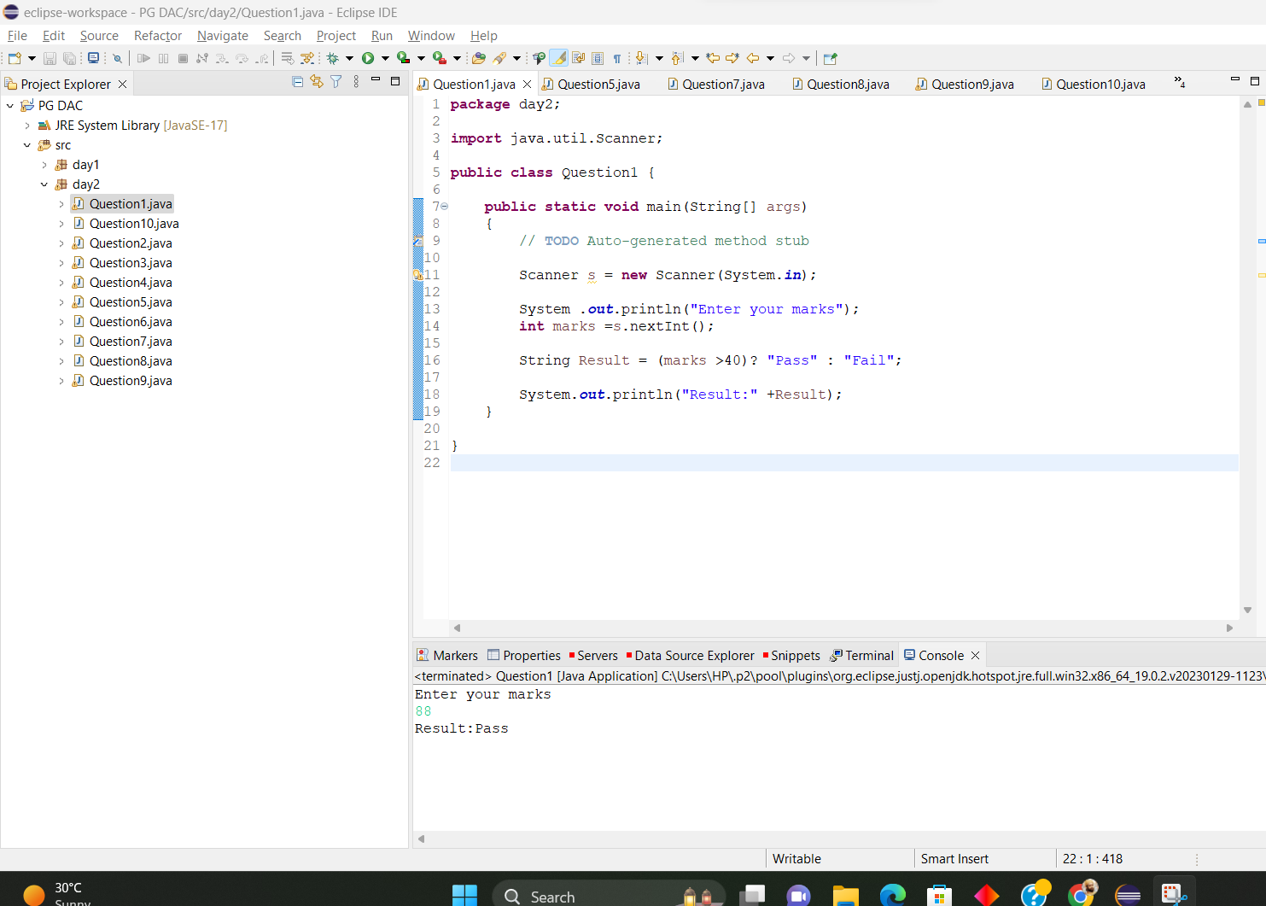

Q.2 using ternary check if number entered by user is positive or negative .  
In case number is positive store "Positive number" else store negative number to Result variable.

Ans:

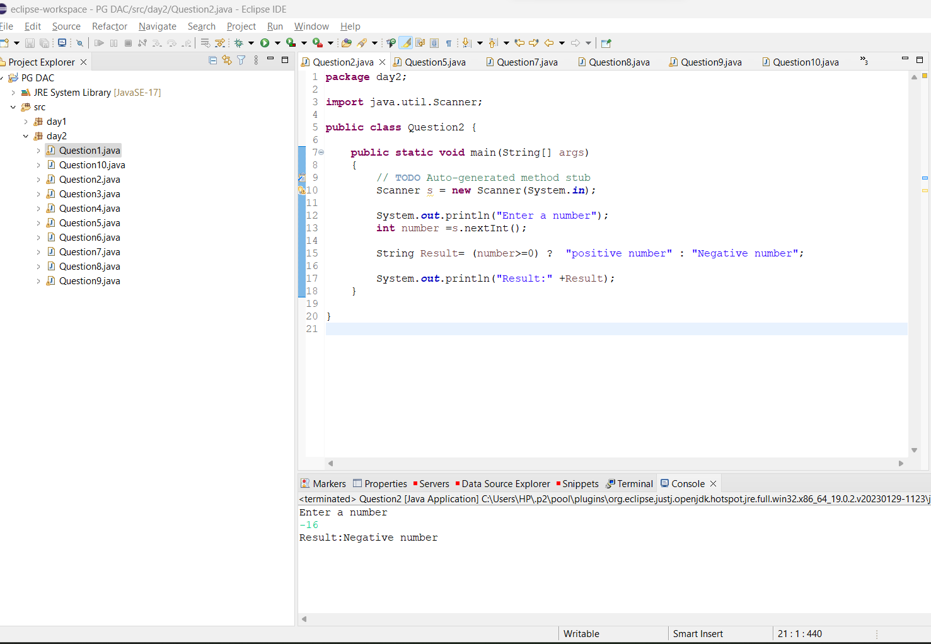

Q3.  WAP to ask name ,age and salary of an employee and print on console.

Ans:

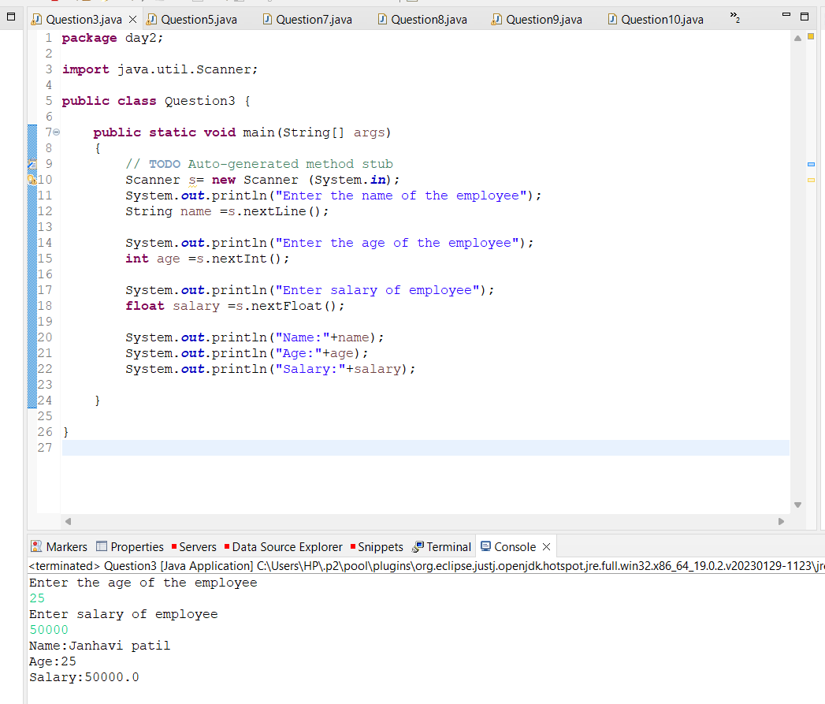

Q.4 .wap  that ask two numbers from user and print greater number among two

Ans:

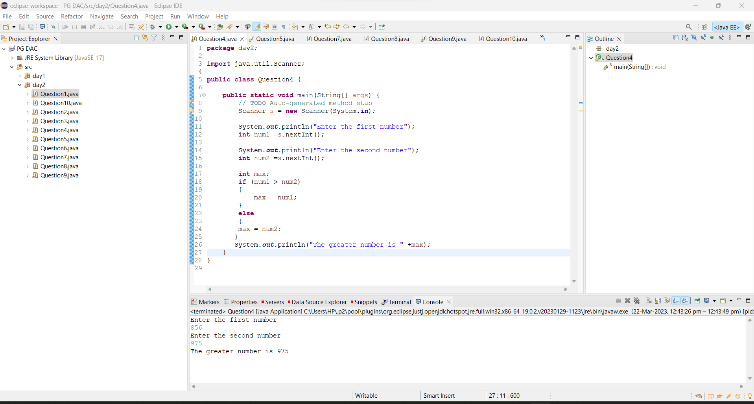

Q.5 wap to ask product name and price of product from user and calculate discount i.e   
 if price > 2000 then discount is 10 percent of price   
 else   
 discount is 7 % of price

Ans:

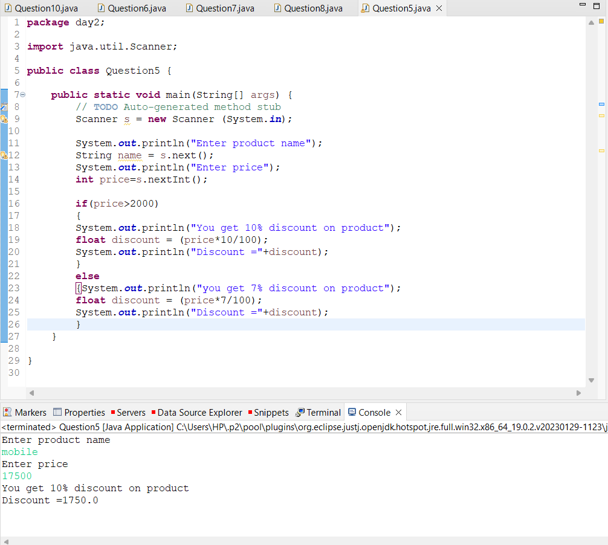

Q.6 Wap to swap two numbers

Ans:

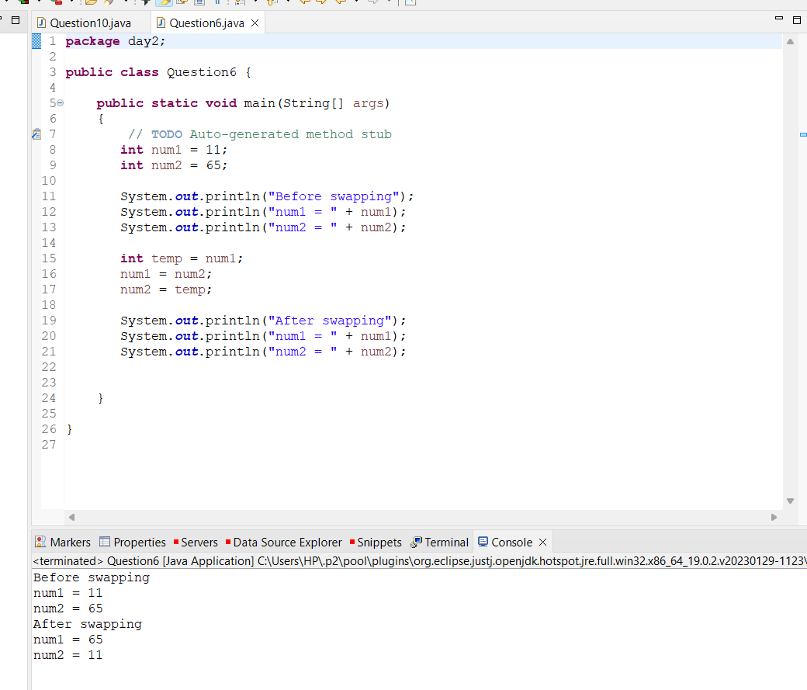

Q.7 How to swap two numbers without using a third variable?

Ans:

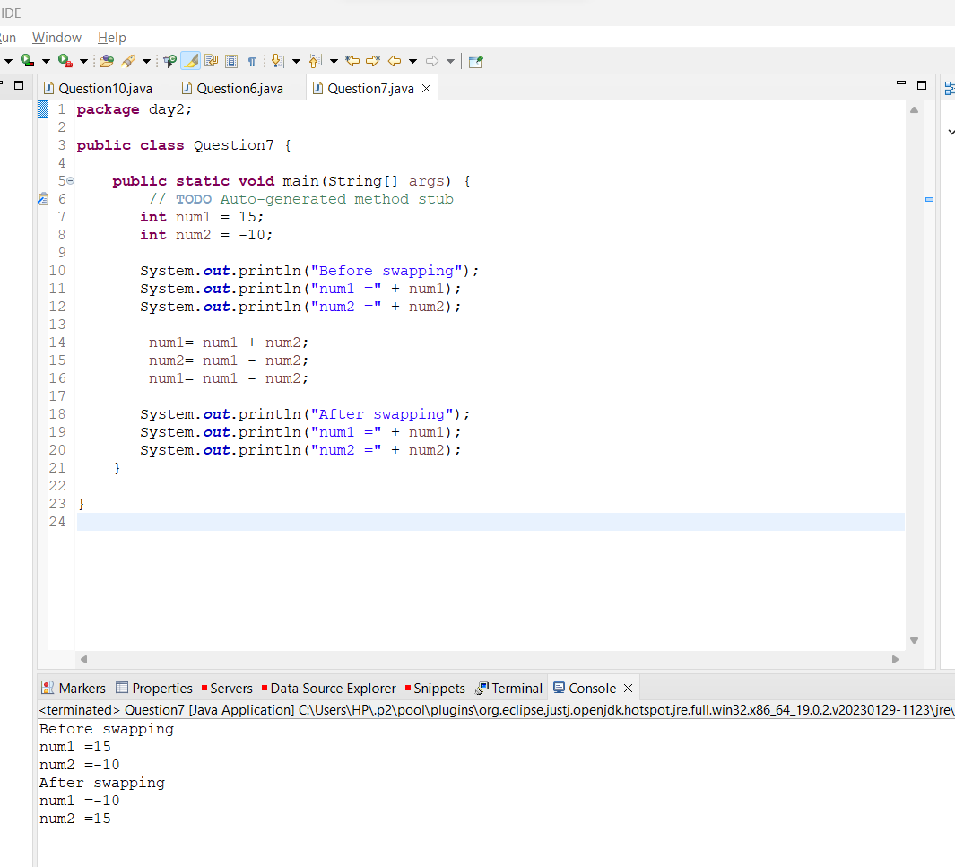

Q.8 wap to check is number is evenor odd.

Ans:

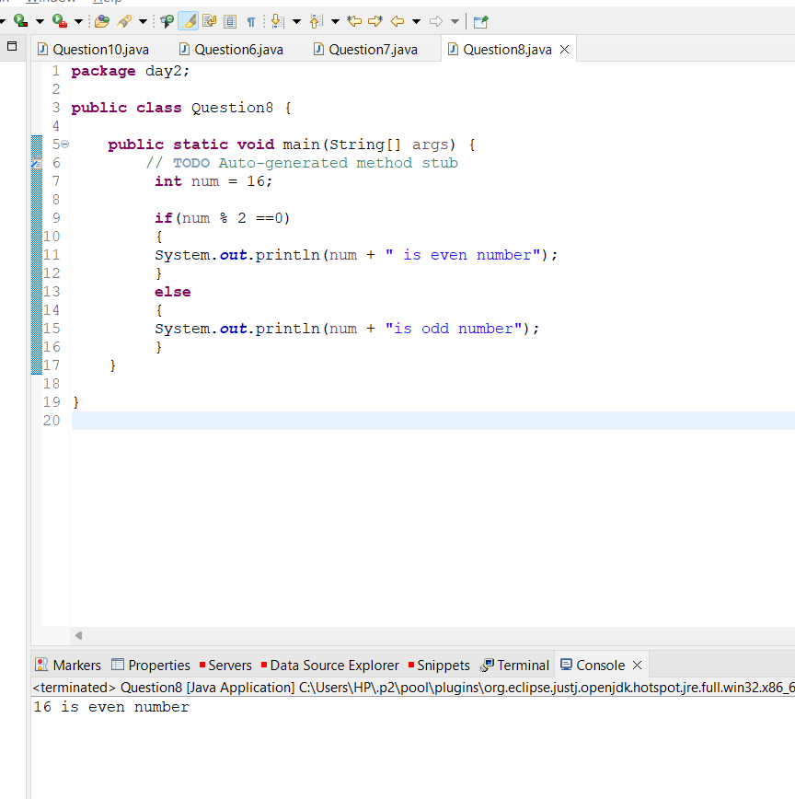

Q.9  A school has following rules for grading system:  
 a. Below 25 - F  
 b. 25 to 45 - E  
 c. 45 to 50 - D  
 d. 50 to 60 - C  
 e. 60 to 80 - B  
 f. Above 80 - A  
 Ask user to enter marks and print the corresponding grade

Ans:

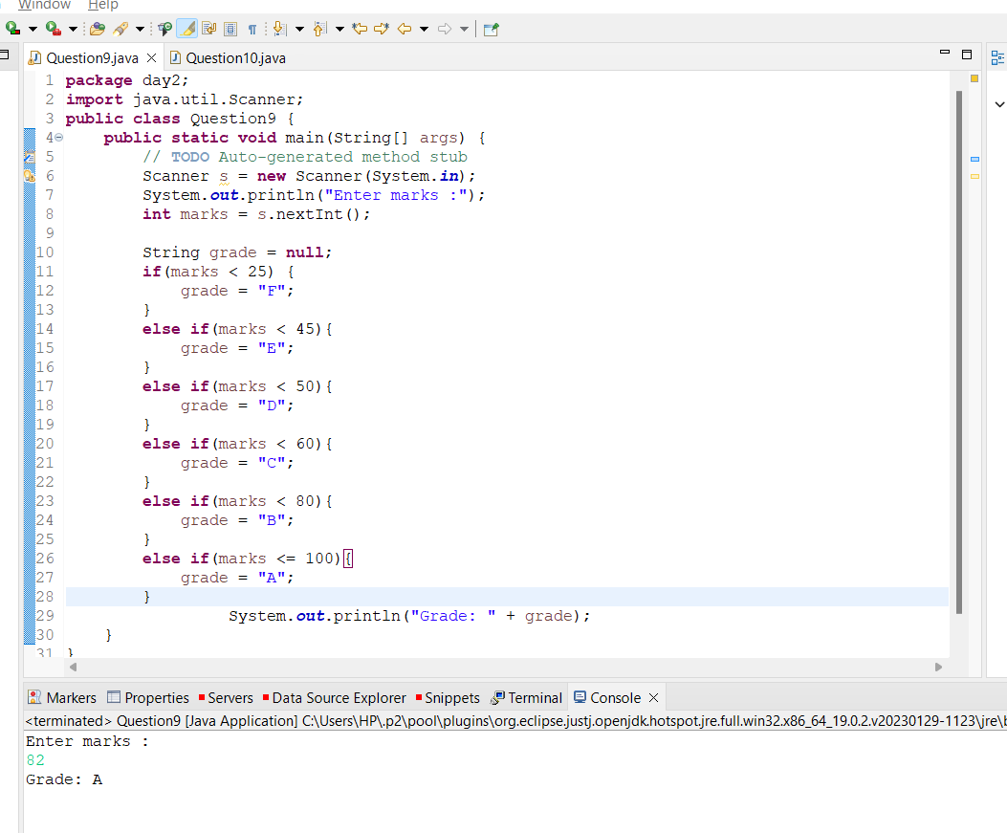

Q.10 wap to check greater number among three numbers

Ans:

